Create the terraform file   
  
  
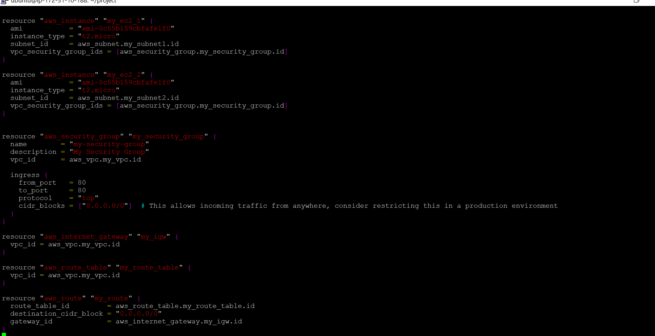  
  
Apply the same and check   
  
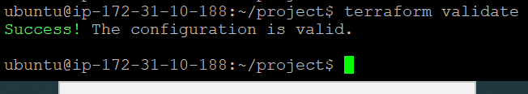  
  
Create the same  
  
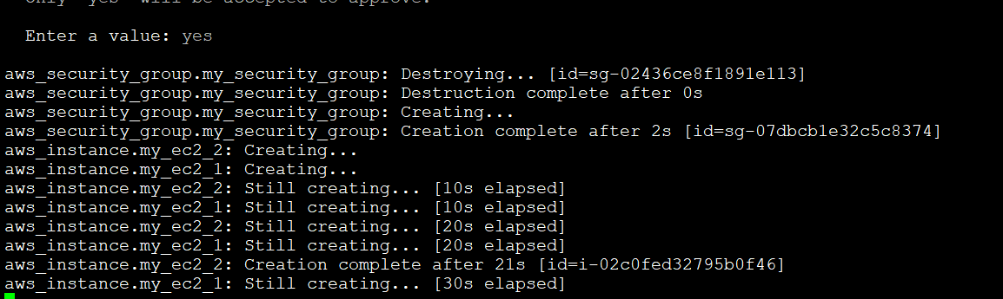

The same is created   
  
  
  
The Other two instances has been created   
  
